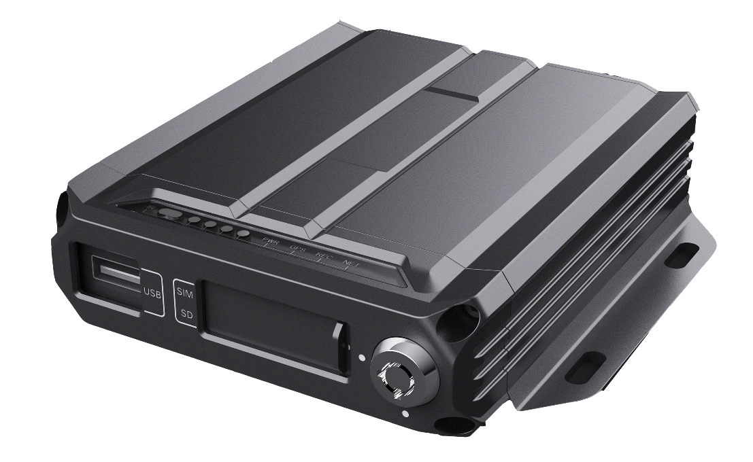

Product introduction
M15Hv is a high-performance, high- expansion product specially developed for in-vehicle video surveillance and remote video surveillance. etc. technology. H15Hv has a compact structure, elegant appearance, and easy installation and use. It is a basic product for lightweight applications. It is suitable for public long distance passenger transportation, road inspection and other automotive mobile monitoring fields.

Product advantages
- The in-vehicle interface can operate reliably and stably in complex environments
- Video encoding H.265, H.264 optional
- Support 4G /5G , GPS function module
- Support one SD card
- Abundant peripheral interfaces
- Support external UPS battery life
- High scalability

core parameters
project |  | Parameter Description
Audio and video input | video input | AHD input: 4ch 1080P , maximum frame rate 120fps
 | audio input | 2 audio inputs
Audio and video output | video output | Default 1 CVBS output (VGA output optional)
 | voice output | 1 channel voice output
Audio and video parameter coding | video encoding | H.264 Main Profile/H.265
 | Video resolution | 1080P/720P/D1 optional
 | audio coding | Default G.726, G.711A optional
storage | SD card | Support 1 SD card
wireless network | 4G wireless | Support 1 SIM card, optional: all mainstream communication modules in the world
Targeting | Beidou/GPS | Support hybrid positioning, speed detection, time synchronization
interface | USB | 1 USB interface, support exporting data
 | serial port | Support 1 RS232, optional 1 RS485 , external sensor
 | I/O | 4 switch inputs, compatible with 1 analog input
 | network port | Optional
Physical Specifications | size | 100 mm (L) * 1 20.8 mm (W) * 32 mm (H) (excluding tail)
 | weight | Bare metal: 0.6 kg  FCL: 0.8kg (with M 15 Hv -SGNE1-L as standard)
working environment | Operating temperature | -20～+70℃
 | Working humidity | 8%~90% (non-condensing)
other | operating mode | Remote control, mobile APP, WEB
 | Gravity Sensing | Built-in GSensor
 | Configurable AI algorithm | Driver identification, people counting, assisted driving, etc.

Product Size
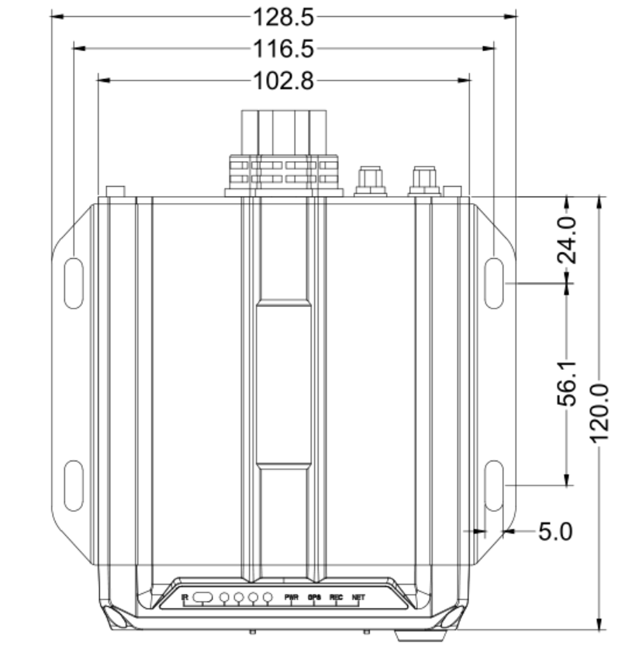
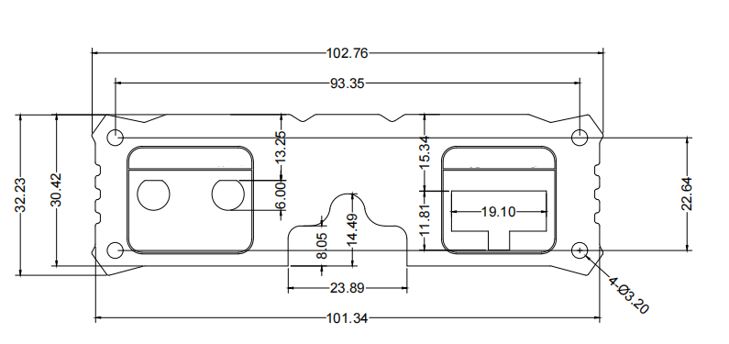
Unit: M M

Panel interface
front panel
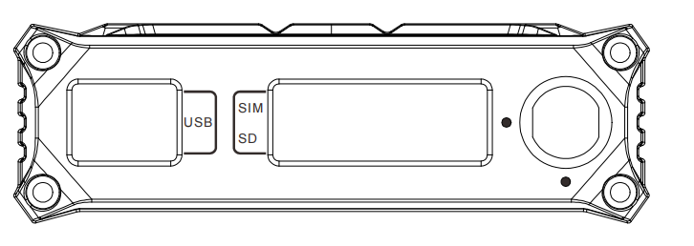
rear panel
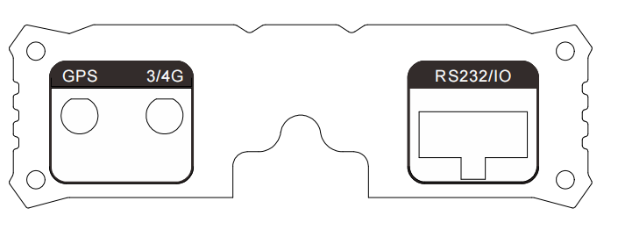
tail line definition
